**Ecuador Plant Design**

**AguaClara**

**Cornell University**

**February 2009**

**Abstract**

The design team of AguaClara has come up with a preliminary design for a plant as per the request of Hugo Castillo. The plant is designed for a flow rate of 3 liters per second, and is powered by gravity. The plant is designed to treat turbid surface waters for distribution systems already in place. The Ecuador plant design contains two separate sedimentation tanks, three flocculators, and an entrance and exit channel. The plant has a footprint of approximately 10.5 square meters.

The following document contains an overview of the plant design, including drawings, dimensions, and overall process descriptions. It should be noted that this is a preliminary design and is subject to change as continuing research brings forth design changes.

**Table of Contents**

**Design Overview** 4

**Entrance Tank** 5

**Flocculator** 6

**Inlet Channel** 7

**Sedimentation Tank** 8

**Sedimentation Tank – Inlet Slopes** 9

**Sedimentation Tank** 10

**Sedimentation Tank – Sludge Drain** 11

**Sedimentation Tank – Lamella** 12

**Sedimentation Tank – Effluent Launder** 13

**Exit Channel** 14

**Design Overview**

The automated design process breaks up the plant design into nine different elements: entrance tank, flocculator, inlet channel, sedimentation inlet slopes, sedimentation tank, settling plates (lamella), sludge drain, sedimentation effluent launder, and exit channel. Given a flow rate and specifications for the materials that will be used, the program is designed to make all necessary calculations and output dimensions for the plant. It is up to on-site engineers to conduct construction details and perform any surveying that may be necessary.

The following report outlines the different design elements and processes associated with the plant, including drawings with dimensions. Every element of the plant follows a variable naming guideline, which can be found online. However, in this report a description is given next to the dimension, with a rendered image showing those dimensions. Please note that the given dimensions are not an exhaustive list, but are a general overview to give an idea of what the plant will look like.

W.FlocChannel

L.Sed

W.ExitChannel

W.InletChannel

H.InletChannel

L.Channel

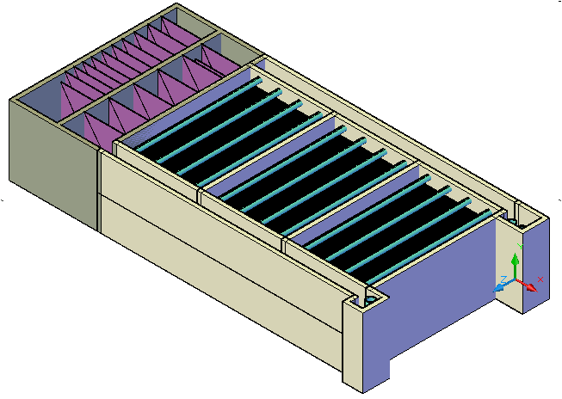

**Entrance Tank**

The entrance tank feeds water from the source to the plant and causes rapid mixing to take place as chemicals are fed into the water. The plant is designed for 60mg/L of aluminum sulfate to serve as coagulant. The water then flows through a riser pipe called a linear flow orifice meter (LFOM) so as to create a linear relationship between the height of the water in the entrance tank and the flow rate through the plant.

The number of orifices and diameter of the orifices are calculated in the program, as well as the diameter of the riser pipe. The dimensions for the entrance tank are also given. The following are the particular dimensions for the plant’s entrance tank:

|  |  |  |
| --- | --- | --- |
| **Dimension** | **MathCAD Variable Name** |  |
| Length | LEt | 1.5m |
| Width | WEt | 0.75m |
| LFOM Pipe Diameter | NDLfom | 12in |
| Height | HEt | 2.02m |

**Flocculator**

The flocculation tanks serve to mix the water with aluminum sulfate to promote flocculation. Flocculation is a simple gravity driven process that creates flocs (collections of particles) which settle out in the sedimentation tank. The flocculator is divided into vertical channels by baffles and the water flows up and down through these channels.

Before entering the floc tank, the water is mixed with aluminum sulfate which acts as a coagulant. Each 180 degree turn through the flocculator encourages mixing and collisions of the particles. Each collision offers a small probability of sticking, and as a floc proceeds through the tank it increases in size. The larger it gets, the more likely it is to settle out in the sedimentation tank.

The flocculation program calculates the dimensions of the flocculator, the number of flocculation tanks/channels needed for adequate mixing, and the number and spacing of the baffles. The baffles are composed of corrugated sheeting, constructed in a set number of modules. Separating the baffles into separate modules allows them to be removed easily and also allows easy access for cleaning the tank.

The following are the dimensions for the flocculation tanks:

|  |  |  |
| --- | --- | --- |
| **Dimension** | **MathCAD Variable Name** |  |
| Width | WFlocChannel | 0.46m |
| Length | LFlocChannel | 2.01m |
| Number of baffles | NFlocBaffles | 91 |
| Number of floc channels | NFlocChannels | 3 |

**Inlet Channel**

Water flows from the flocculator into the sedimentation tanks via the inlet channel. The channel runs along the inlet end of the sedimentation tanks, such that its length will be equal to the sum of the widths of the sedimentation tanks. The width and depth of the channel depend on the water level in the sedimentation tank, which is designed to be the same as in the channel and the flocculator.

The primary constraint for the inlet channel is the depth. The channel is designed to make sure that the transition between the flocculator and sedimentation tanks does not break up the flocs formed in the flocculator. The following are the dimensions for the plant’s inlet channel:

|  |  |  |
| --- | --- | --- |
| **Dimension** | **MathCAD Variable Name** |  |
| Width | WInletChannel | 0.21m |
| Height | HInletChannel | 0.563m |
| Length | LChannel | 2.14m |

**Sedimentation Tank**

The following five sections describe the overall design of the sedimentation tanks. For reference, the following is a cross-section of the sedimentation tank:

An.SedBottom

ND.SedSludge

AN.SedTopInlet

Z.SedSlopes

ND.SedLaunder

B.SedPort

H.Sed

L.SedPlate

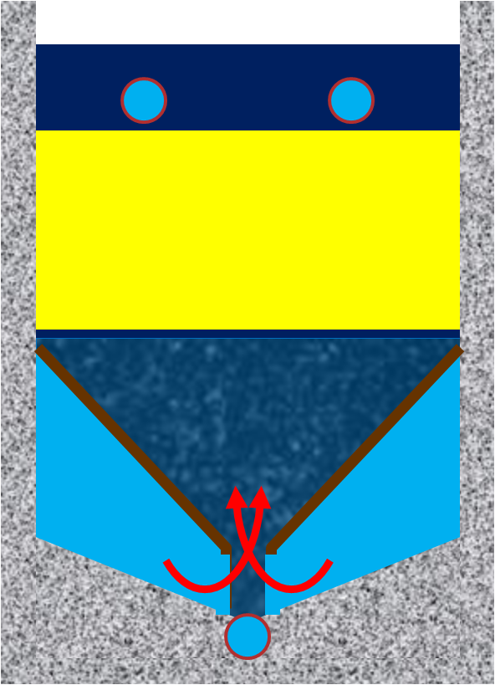

W.Sed

**Sedimentation Tank – Inlet Slopes**

Water flows from the inlet channel into the sedimentation tanks through a manifold, also known as the sedimentation inlet slopes. These channels run along the length of the sedimentation tank and uniformly distribute water to the entire bottom of the tank, thus creating a uniform flow of water out of the slopes through ports and into the tank.

One of the major concerns with this design is ensuring the water flows uniformly into the sedimentation tank and that the velocity does not get too high as to break up the flocs. However, the velocity must be high enough so that the flocs don’t settle in the slopes and decrease the area of the ports through which the water flows out.

The sedimentation tank for this plant is designed as a triangle due to the relatively low flow rate the plant is designed to handle. The ports are given as an area, and the shape can be determined later based on construction materials. However, the ports are recommended to be either square or rectangular. The following are the dimensions for the design of the sedimentation inlet slopes:

|  |  |  |
| --- | --- | --- |
| **Dimension** | **MathCAD Variable Name** |  |
| Top angle of the slope | ANSedTopInlet | 60 deg |
| Bottom angle of the slope | ANSedBottom | 10 deg |
| Vertical height of the slope | ZSedSlopes | 0.937m |
| Number of slopes in each sedimentation tank | NTrianglesperTank | 2 |
| Number of ports in each slope | N­SedPorts | 17 |
| Center to center spacing between ports | BSedPort | 5.8cm |

**Sedimentation Tank**

The design of the sedimentation tank is a critical piece of the design of the entire plant. Its properties, such as depth and critical velocity, are important in determining the dimensions and lamella spacing. The sedimentation tanks are designed to handle the plant’s flow rate. The number of sedimentation tanks is set by the user, and has been set at two for this specific design. The length and width are then determined so as to create uniform flow into the sedimentation tanks without breaking the flocs.

The following are the dimensions for the sedimentation tanks:

|  |  |  |
| --- | --- | --- |
| **Dimension** | **MathCAD Variable Name** |  |
| Number of sedimentation tanks | NSedTanks | 2 |
| Height | HSed | 1.65m |
| Length | LSed | 2.01m |
| Width | WSed | 0.92m |
| Number of ports | NTrianglesperTank | 2 |

**Sedimentation Tank – Sludge Drain**

The sedimentation tank also includes a sludge drain for the settled flocs to be drained. The sludge drain runs along the bottom of each sedimentation tank and collects the flocs as they fall from the lamella and settle. The number of orifices in the sludge drain is determined by the length of the sedimentation tank and the spacing between each orifice, as defined by the user. The following are the dimensions for the sludge drain:

|  |  |  |
| --- | --- | --- |
| **Dimension** | **MathCAD Variable Name** |  |
| Number of orifices | NSedSludgeOrifices | 13 |
| Diameter of orifices | DSedSludgeOrifices | 0.5in |
| Center to center distance between orifices | BSedSludgeOrifices | 15cm |
| Diameter of the sludge drain | NDSedSludge | 2 |

**Sedimentation Tank – Lamella**

The lamella (sometimes referred to as plate settlers) are located within each sedimentation tank and serve to promote the settling of the flocs. Similar to the construction of the baffles in the flocculator, they are composed of corrugated sheets, however they are constructed at a specified angle. As water flows up through the sedimentation tank, the flocs will collide with the lamella, thus increasing the likelihood of settling.

The important parameters in the design of the lamella are the critical velocity (10m/day) and the upward velocity at the bottom of the tank (70m/day). The critical velocity is the rate at which a particle must fall to ensure that it settles out within the plate settlers. The upward velocity at the bottom of the tank is important for the formation of the sludge blanket, which can be incorporated into the sedimentation tank. Research is still being conducted on this part of the plant and details for the floc blanket will be sent separately.

Note that each sheet is referred to as a “plate” and the plates make up the entire lamella. The following are the dimensions for the lamella.

|  |  |  |
| --- | --- | --- |
| **Dimension** | **MathCAD Variable Name** |  |
| Center to center distance between each plate | BSedPlate | 1.637cm |
| Length of the plate | LSedPlate | 0.471m |
| Number of plates | NSedPlates | 58 |
| Angle of the plates | ANSedPlate | 60 deg |
| Velocity through the lamella | VSedUp | 70m/day |

L.SedPlate

B.SedPlate

AN.SedPlate

**Sedimentation Tank – Effluent Launder**

The launder is the manifold that transports the clean water from the top of the sedimentation tank to the exit channel. The launder is located between the top of the lamella and the surface of the water in the sedimentation tank, and runs along the middle of the tank. Orifices are drilled along the launder to carry the water through the manifold, similar to that of the sludge drain. Each launder will have two rows of orifices oriented downward, thereby avoiding the capture of any resulting floating floc that might occur at the surface of the sedimentation tank.

The following are the dimensions for the launders:

|  |  |  |
| --- | --- | --- |
| **Dimension** | **MathCAD Variable Name** |  |
| Diameter of launder | NDSedLaunder | 3in |
| Number of orifices in launder (per row) | NSedLaunderOrifices | 28 |
| Diameter of orifices | DSedLaunderOrifices | 0.313in |

**Exit Channel**

The exit channel transports the water from the sedimentation tank, via the launder, and out of the plant. Chlorine is added to the water at the end of the exit channel and flows through the outlet weir. The outlet weir controls the flow to the storage tank and determines the water level throughout the entire plant. The exit channel is very similar to the design of the inlet channel in layout, however the way in which the water enters and leaves is very different.

The following are the dimensions for the exit channel:

|  |  |  |
| --- | --- | --- |
| **Dimension** | **MathCAD Variable Name** |  |
| Width | WExitChannel | 0.208m |
| Height | HExitChannel | 0.563m |
| Length | LExitChannel | 2.14m |